The Daily Informer
Self-Harm Awareness

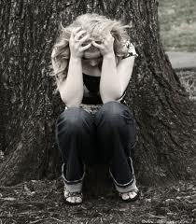
How do you deal with feeling alone? Call some friends? Watch a movie? Eat your favorite snack? Well many teens and young adults turn to self-harm. Self-harm is seen as an escape from emotional pain. There are many types of self-harm. Such as:
- Cutting
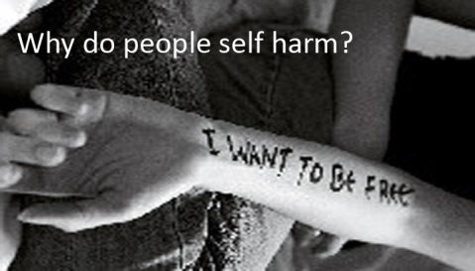
- Burning
- Interfering with wound healing (picking or reopening wounds)
- Punching or hitting oneself or other objects
- Inserting objects into the skin
- Purposely bruising or breaking one's bones
- Certain forms of hair pulling
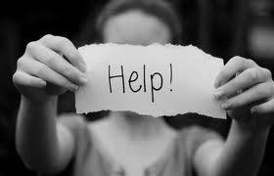
Research has shown that most people who self-harm also suffer from:
- Eating disorders
- Depression
- Anxiety disorders
- Substance abuse
- Conduct and oppositional disorders
Most people feel it’s the only thing they can do to cope with their pain. They don’t see anything else they can do to stop it. It doesn’t stop the pain completely though. “It’s like slapping on a Band-Aid when what you really need are stitches. It may temporarily stop the bleeding, but it doesn’t fix the underlying injury.”-HelpGuide.org. It creates problems of its own. You feel more pain than you did from the start because to add up on top of all the emotional pain you now have physical pain. It solves nothing and former self-harmers can tell you this. Most people regret it, so they feel guilty. That adds more sadness and makes them mad at themselves for doing it, some are so mad they do it again because they feel they deserve the pain. Let me clear this up, most self-harmers are not crazy or dangerous as most may think, they are just sad and lonely. They want someone to care and they feel like no one does. Putting a “crazy” or “dangerous” label doesn’t help anything; it just makes them feel worse about themselves.

Statistics

“Each year, 1 in 5 females and 1 in 7 males engage in self-injury. 90 percent of people who engage in self harm begin during their teen or pre-adolescent years. Nearly 50 percent of those who engage in self-injury activities have been sexually abused. Females comprise 60 percent of those who engage in self-injurious behavior. About 50 percent of those who engage in self-mutilation begin around age 14 and carry on into their 20s. Many of those who self-injure report learning how to do so from friends or pro self-injury websites. Approximately two million cases are reported annually in the U.S.”-Healthy Place, Self-Injury, Self-Harm Statistics and Facts

Myths and facts about cutting and self-harm
Many people don’t know many things about self-harmers so they make things up and other believe them. To clear those up here are some myths and the facts:

Myth: People who cut and self-injure are trying to get attention.
Fact: Most aren’t. The majority of people who do self-harm do not show other people, they hide it and do it in private. If someone happens to see it they will most likely lie and say it’s an animal that attacked them, the most common lie I’ve seen is it was their cat.

Myth: People who self-injure want to die.
Fact: Not true, some maybe, but most do it as a way to cope with living because they want to live on. Self-harmers are more likely to commit suicide, but that doesn’t mean they all want to die.

Myth: If the wounds aren’t bad, it’s not that serious.
Fact: The pain that people are in is not measured by how deep the wounds are. That would be like saying your grades show how intelligent you are. That is not true either; my mom got bad grades in school and has an IQ of 132. Who has the right to judge another’s pain?

Signs of Self-Harm

Self-harm can be hidden very easily but clothing. So here are a few major signs that someone might be (keep on mind there are

more signs than just these, if you haven’t noticed these but think they are don’t write it off as an option):
- Unexplained wounds or scars from cuts, bruises, or burns, usually on the wrists, arms, thighs, or chest.
- Blood stains on clothing, towels, or bedding; blood-soaked tissues.
- Sharp objects or cutting instruments, such as razors, knives, needles, glass shards, or bottle caps, in the person’s belongings.
- Frequent “accidents.” Someone who self-harms may claim to be clumsy or have many mishaps, in order to explain away injuries.
- Covering up. A person who self-injures may insist on wearing long sleeves or long pants, even in hot weather.
- Needing to be alone for long periods of time, especially in the bedroom or bathroom.
- Isolation and irritability.
-HelpGuide.org

How to Help a Self-Harmer

Simple, listen. They don’t always need advice. They just need someone to care. The person will most likely need a therapist, but all you need to worry about is caring about them and showing you care. If they cry, hug them, don’t even say anything. It’s really easy. Even if you think they might but you don’t know for sure, just ask if they are okay, and keep asking till they give you something other than a one word answer. Most people will lie to hide it because they think if they tell someone they will leave them. Show them that you won’t leave. They trust you a lot to tell you something so deep and personal.

Show them that there are things to do other than self-harm. I found some great ones on a website:

If you cut to express pain and intense emotions:

- Paint, draw, or scribble on a big piece of paper with red ink or paint
- Express your feelings in a journal
- Compose a poem or song to say what you feel
- Write down any negative feelings and then rip the paper up
- Listen to music that expresses what you’re feeling

If you cut to calm and soothe yourself:
- Take a bath or hot shower
- Pet or cuddle with a dog or cat
- Wrap yourself in a warm blanket
- Massage your neck, hands, and feet
- Listen to calming music

If you cut because you feel disconnected and numb:

- Call a friend (you don’t have to talk about self-harm)

